23nd International Spring Tourism Fair

**Minsk, 2–4 April 2020**

# LEISURE-2020

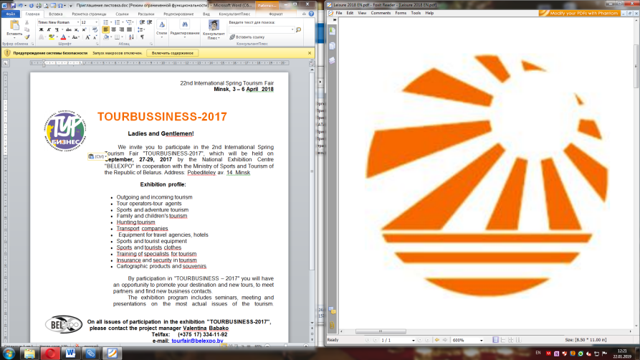

**Ladies and Gentlemen!**

We invite you to participate in the 23nd International Spring Tourism Fair "LEISURE-2020", which will be held on **2–4 April, 2020** by the National Exhibition Centre "BELEXPO" in cooperation with the Ministry of Sports and Tourism of the Republic of Belarus.

Address: 14 Pobediteley ave., Minsk

**Exhibition profile:**

* Travelling (business, leisure, educational and incentive tours, vacation programs for children)
* Excursion programs
* Transport services
* Sport-inventory
* Insurance services in tourism
* Guesthouses, spa and health resorts
* Hotel services
* Goods for sports and recreation
* Maps, guides, leaflets and brochures

By participation in "LEISURE – 2020" you will have an opportunity to promote your destination and new tours, to meet partners and find new business contacts.

The exhibition program includes seminars, meeting and presentations on the most actual issues of tourism.



On all issues of participation in the exhibition "LEISURE-2020", please contact   
the Project Manager:

**Natalia Khrol**

Tel./fax: (city): +375 17 334 01 31

+375 29 889 56 63 (Telegram, WhatsApp)

E-mail: [tourfair@belexpo.by](mailto:tourfair@belexpo.by)

**Marina Prozorova**

Tel./fax: (city): +375 17 334 01 54

+375 29 887 22 90 (Viber, WhatsApp)

National Exhibition Centre "BELEXPO"   
of The Presidential Property Management Directorate